**Project Development Phase**

**Model Performance Test**

|  |  |
| --- | --- |
| Team ID | PNT2022TMID18532 |
| Project Name | Estimate The Crop Yield Using Data Analytics |

**Model Performance Testing:**

Project team shall fill the following information in model performance testing template.

|  |  |  |
| --- | --- | --- |
| **S.No.** | **Parameter** | **Screenshot / Values** |
| 1. | Dashboard design | No of Visulizations / Graphs – 4 / 16 |
| 2. | Data Responsiveness | CROP PRODUCTION DATASET  The dataset contains 7 rows and 246091 record and dataset contains different state name, different district name, crop year ,crop, area, season and production |
| 3. | Amount Data to Rendered  (DB2 Metrics) | To connect IBM Db2 database cloud with cognos analytics By using IBM Db2 to create Dashbord,Report,Story,Visualization and Exploratory data analytics(EDA) |
| 4. | Utilization of Data Filters | Utilization of data filters - 25 |

5. Effective User Story No of Scene Added – 12

6. Descriptive Reports No of Visulizations / Graphs – 1 / 6

REPORT:

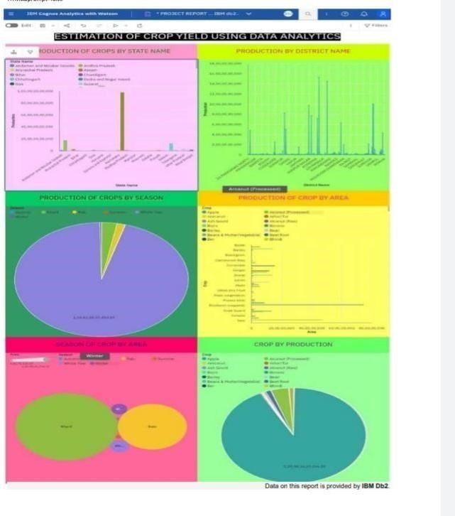

STORY:

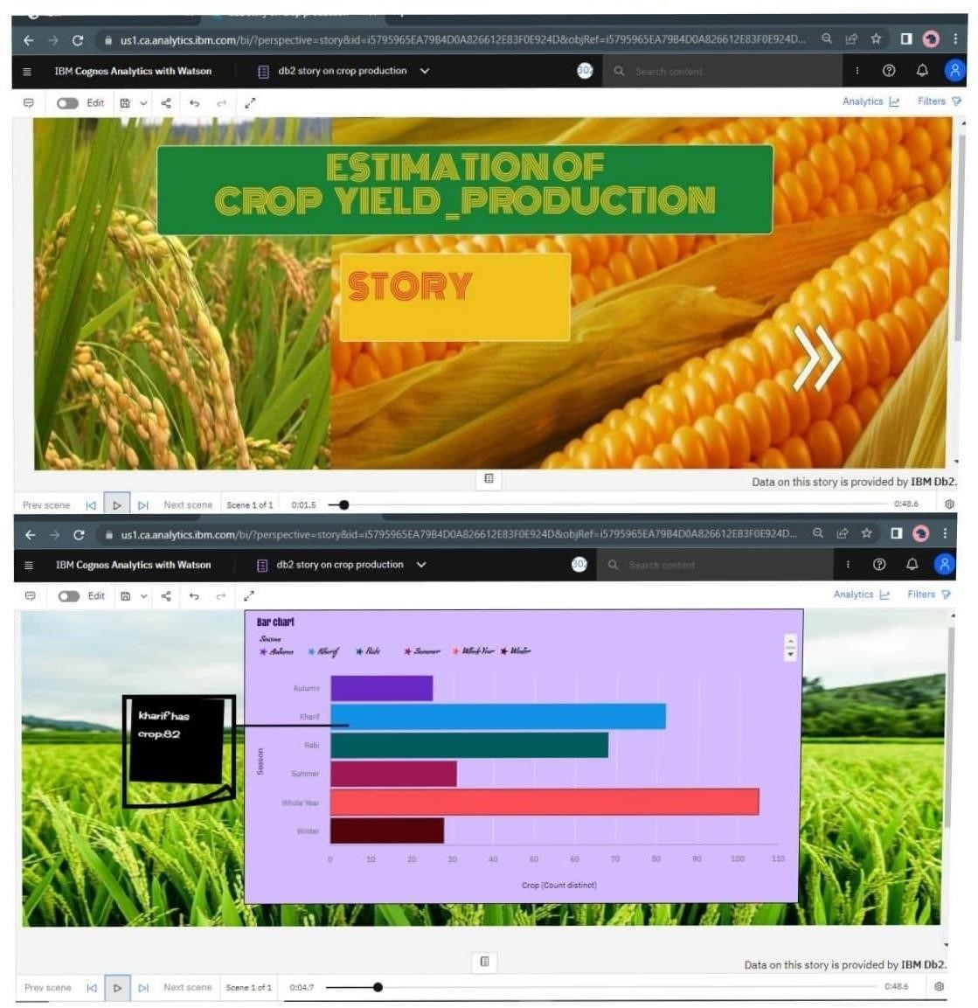

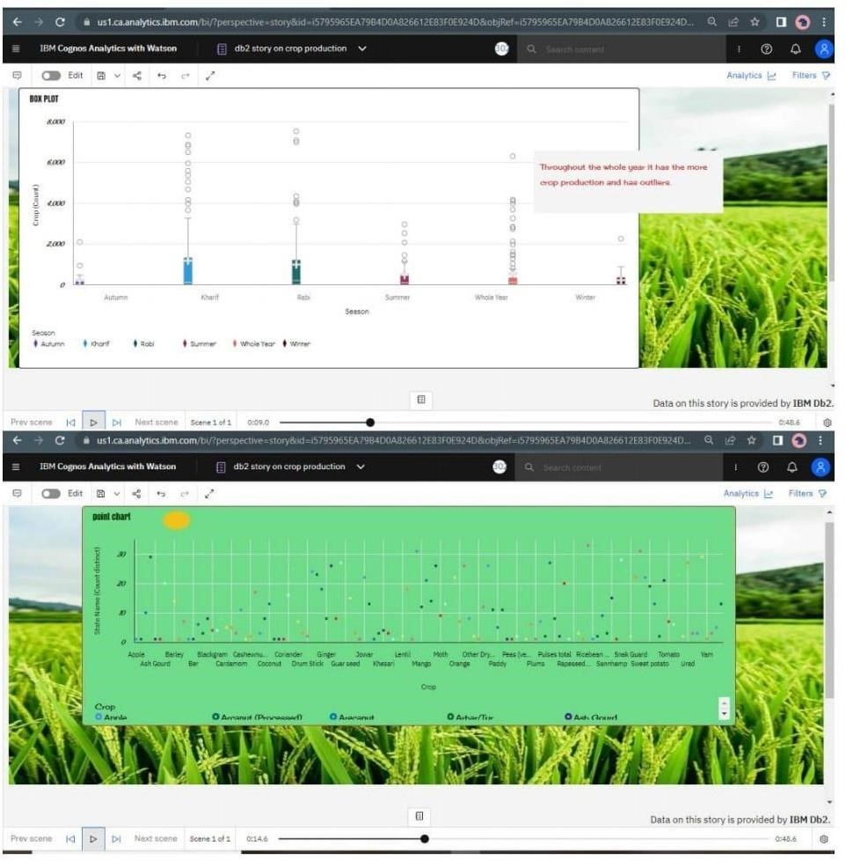

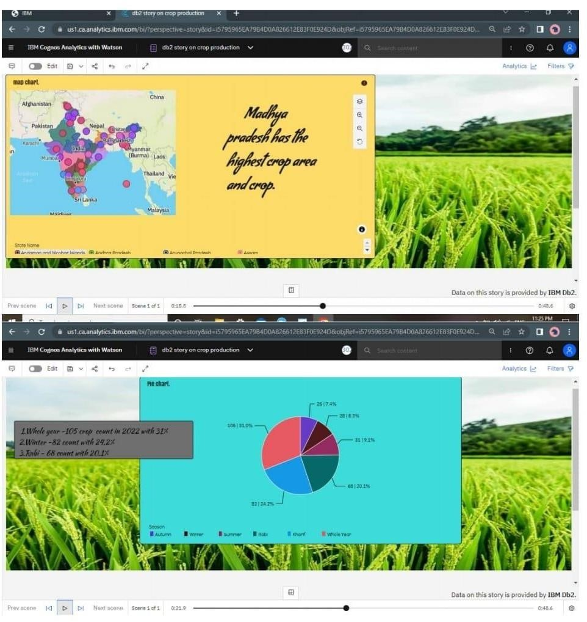

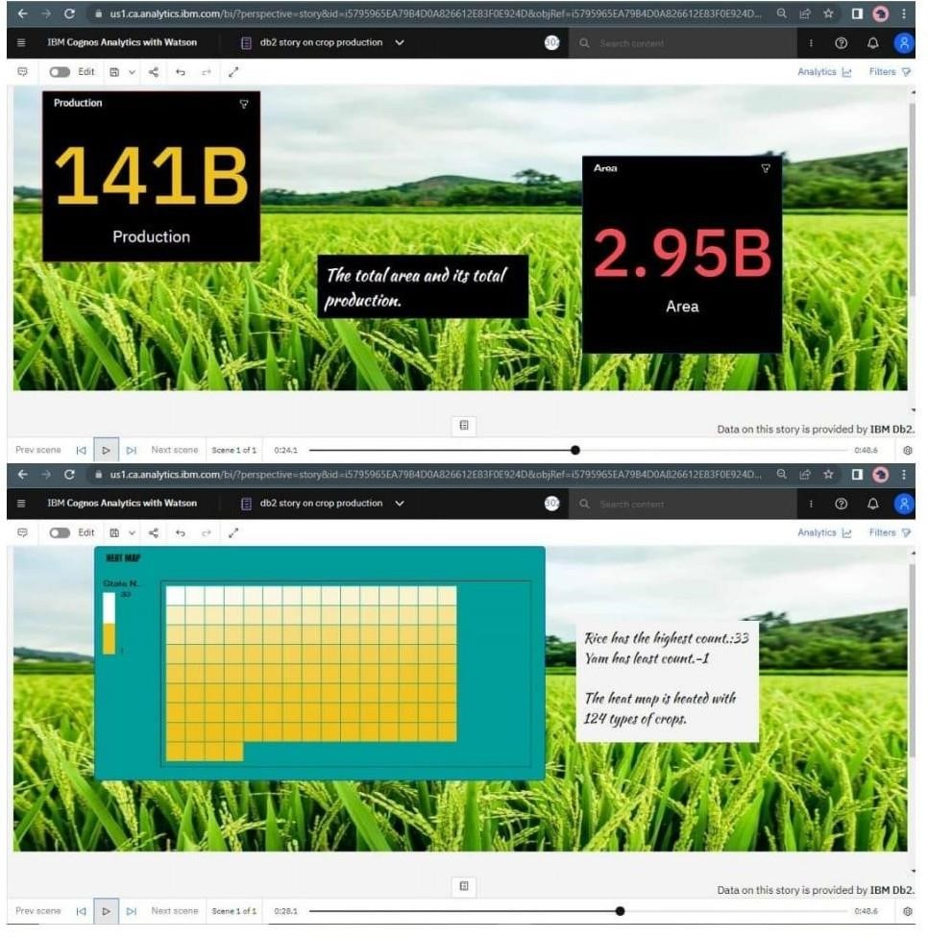

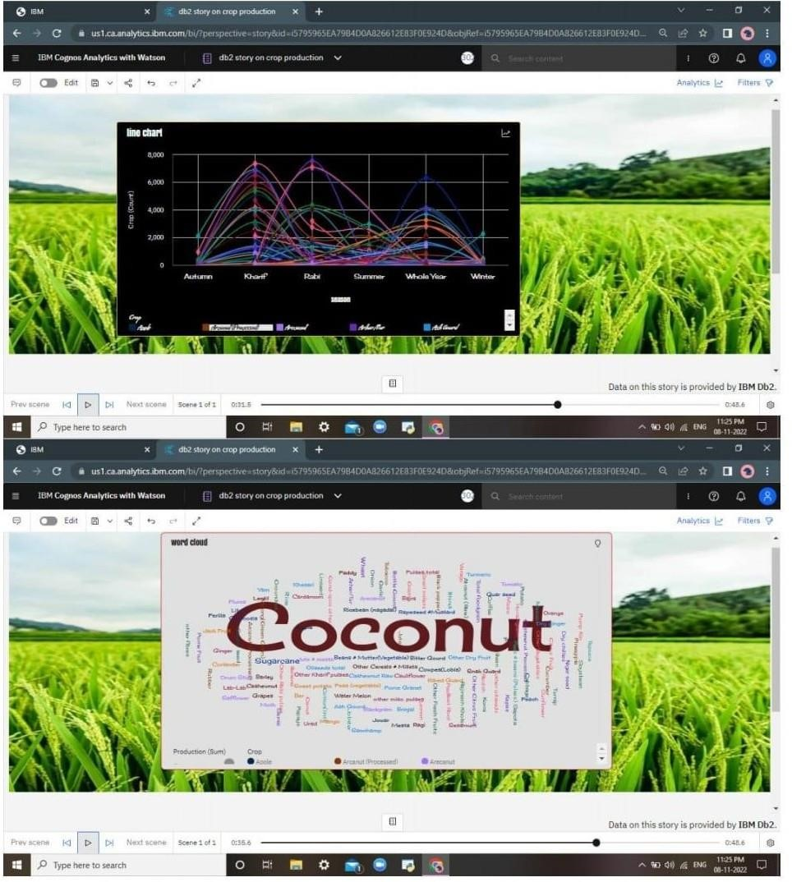

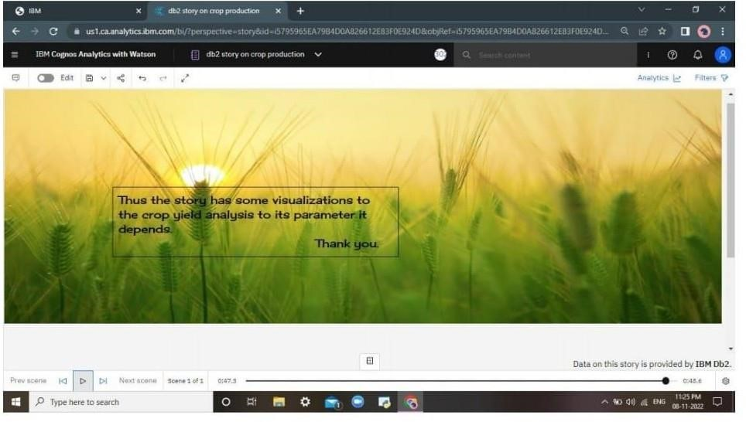

DASHBOARD:

